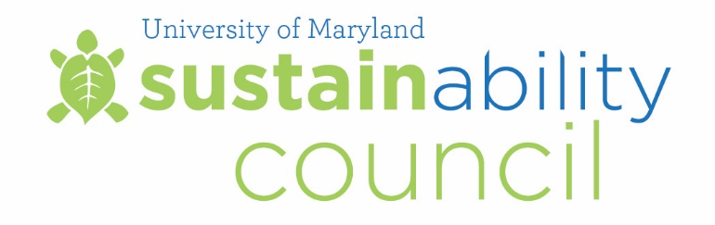

Meeting Summary
November 20, 2015

Council Members Present:

Carlo Colella, Vice President for Administration and Finance (Chair)
Linda Clement, Vice President for Student Affairs
Cindy Hale, Associate Vice President, Office of the Provost
Eric Wachsman, Professor, Materials Science and Engineering, and Director, Energy Research Center
Scott Lupin, Associate Director, Environmental Safety, and Director, Office of Sustainability
Mary-Ann Ibeziako, Director, Department of Engineering and Energy
David Barks, Assistant Director of Systems Architecture, Division of IT
Steve Cohan, Professor of Practice, Plant Science and Landscape Architecture
Samantha Bingaman, Undergraduate Student, Environmental Science and Policy
Todd Ross McGarvey, Graduate Student, Public Policy

Meeting start time: 9:00am

Meeting Highlights

Welcome and Review of October 16, 2015 Meeting Minutes
Carlo Colella welcomed the Council members and called the meeting to order.

University Sustainability Fund Projects
Samantha Bingaman presented five University Sustainability Fund projects to the Council for review:

Living Wall in University Libraries
This grant will support the design and construction of a living or “green” wall in McKeldin Library. Installation of a green wall will do much to enhance the overall air quality and aesthetics in the Libraries in addition to potentially having a positive effect on overall energy efficiency. The administration of the Libraries is interested in ongoing aesthetic and functional improvements to library spaces on campus. The Libraries will match funding and handle maintenance costs. The Council voted to approve the request for $30,000.
Clarice LED and Water Filling Station Project
In an effort to minimize waste in their facility, The Clarice wants to install additional water filling stations in the building. The student subcommittee approved funding for filling stations but not for LED fixtures. The Fund will not cover maintenance for the stations. The Clarice will cover all other costs. The Council voted to approve the request for $5,000.

Shower Meters to Reduce Water Consumption
Team Shower Power, a group of College Park Scholars (ETE) students, plans to install shower meters in the residential hall bathrooms that would collect data on students’ water consumption use. The Council voted to approve the request for $4,260.

Transforming Student Culture through Green Housing
The Department of Resident Life and the Department of Fraternity and Sorority Life wish to develop and launch new Green Room and Green Chapter programs to grow the culture of sustainable living for residential student populations. The Fund would cover the costs to pilot a full-time staff position shared by the Office of Sustainability, Resident Life and Fraternity and Sorority Life for two years. The Council voted to approve the request for $112,458.

Trash-College Park Scholars Theme
Trash: The Problem of Waste in Our Lives and World is a project of education and outreach being undertaken this academic year by College Park Scholars. Scholars has requested funding to assist with their programs, events and outreach as a part of their trash education project. The Council voted to approve the request for $7,500.

Energy Initiatives Update
Mary-Ann Ibeziako, Director, Department of Engineering and Energy, presented an update on a consultant study of the campus central energy system. The update included an Overview of the Current Systems; Condition Assessment Summary; Proposed Infrastructure Recommendations; Comparison of Central vs. District Approach; Risks of Large Biomass System; Recommendations and Next Steps. See Appendix A for full report.

Climate Action Plan Update (CAP 2.0)
Mark Stewart, Senior Project Manager, Office of Sustainability, presented an update on the progress of a revised campus Climate Action Plan. The update included a breakdown of the revised Waste Strategies chapter. Highlights of strategies included: Reduce Solid Waste Generation; Recycle Appropriate Solid Waste and Compost Appropriate Organic Waste; Target Goals: Individual Recycling Rates 60% by 2020, 65% by 2025; Education and Outreach to Promote Waste Reduction, Recycling and Composting; Divert Solid Waste from Landfill; Maintain at least a 75% institutional diversion rate. See Appendix B for report.

Mark also informed The Council that the Carbon Offset Report would be ready to be reviewed by the December meeting.

Adjourn: 10:30am

