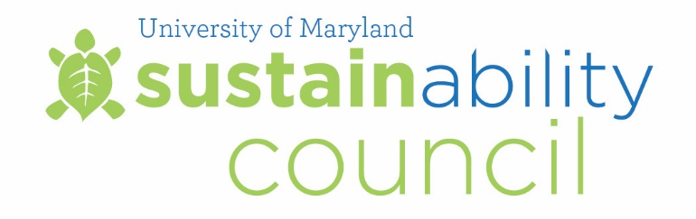

Meeting Summary
March 10, 2017

Council Members Present:

Carlo Colella, Vice President for Administration and Finance (Chair)
Linda Clement, Vice President for Student Affairs
Steve Fetter, Associate Provost
Maureen Kotlas, Executive Director, Environmental Safety, Sustainability & Risk
Scott Lupin, Assoc. Dir., Environmental Safety, Sustainability & Risk, and Director, Office of Sustainability
Jelena Srebric, Professor, Mechanical Engineering
Joseph Sullivan, Professor, Plant Science and Landscape Architecture
Steve Cohan, Professor of Practice, Plant Science and Landscape Architecture
Chauncey Jenkins, Facilities Operations Manager, Department of Engineering and Energy
Samantha Bingaman, Undergraduate Student, Environmental Science and Policy
Adria Schwarber, Graduate Student, School of Public Policy

Meeting start time: 10:00am

Meeting Highlights

Welcome and Review of December 1, 2016 Meeting Minutes

Carlo Colella welcomed the Council members and called the meeting to order. Meeting summary from December 1, 2016 was approved.

Green Terp and Green Chapter Pilot Program presentation
Aynsley Toews from the Office of Sustainability presented the Council with an update on the Green Terp and Green Chapter pilot programs. A copy of the presentation can be viewed as Appendix A.
University Sustainability Fund Projects

Samantha Bingaman, undergraduate representative, presented twelve University Sustainability Fund projects to the Council for review. Project details can be viewed as Appendix B.

The Council reviewed the following projects:
Master’s Degree in Sustainability
The Council voted to approve the request of $90,000. The project had been previously tabled until Dr. Srebic could speak with Associate Provost Beise. The grant proposes the initiation of a degree with eclectic, interdisciplinary curriculum, and a 24-month postdoctoral research associate salary. APPROVED.

Terps Heart the Tap, part 3
The Council voted to approve the request of $67,250. The grant will cover installation costs and filters. APPROVED.

Student Leadership in Community Sustainability and Resiliency
The Council voted to approve the request of $50,000. The grant will cover supplies and student staff support. APPROVED.

Sustainable Technologies Project at UMD
The project requests a grant of $33,645. The grant will cover supplies and student staff support. Tabled until more information can be provided about how the project will be able to sustain itself without direct support from the Fund. TABLED.

LED light controls in Ritchie Coliseum
The Council voted to approve the request of $11,078. The grant will cover materials, equipment, and costs for experiments. APPROVED.

Adaptive Reuse of Existing Buildings
The Council voted to approve the request of $9,490. The grant will cover materials and student compensation. APPROVED.
Recycling Receptacles for RecWell
The Council voted to approve the request of $7,800. The grant will cover powder coating for existing trash bins. APPROVED.
Carbon Management Course
The Council voted to approve the request of $5,000. The grant will cover stipend for part-time professor, field and travel supplies. APPROVED.
Whole Earth Exhibition
The Council voted to approve the request of $4,000. The grant will cover exhibition costs. The Council would like to see if it is possible to extend the exhibit beyond the proposed two-week run time. APPROVED.
Recycling Receptacles in Old Town
The Council voted to approve the request of $3,415. The grant will cover bin costs. APPROVED.
Gemstone Research Projects
The Council voted to approve the request of $1,440 for Team MELTS and $4,034 for Team OYSTERS. The grants for both projects will cover research costs. APPROVED.

Sustainability Fund Signage
The Council voted to approve the request of $2,000 to create new Sustainability Fund signage for projects on campus. APPROVED.

President’s Energy Initiatives
Chauncey Jenkins from the Department of Engineering and Energy provided an update about the first meeting of the President’s Energy Initiatives taskforce. The group has been assembled to evaluate how they can put together best practices and come back together as a group to evaluate and see how their work relates back to the Climate Action Plan. Chauncey also shared that improvements have been made to the university energy dashboard. The dashboard can be viewed here.

Open discussion items
- Carlo Colella shared that he anticipates an announcement coming soon about the Carbon Neutral Air Travel Initiative to the university community.
- Andrew Muir shared that a new video about the Sustainability Fund will be airing on the Big Ten Network. The video can be viewed here.
- Scott Lupin shared that Mark Stewart and Sally DeLeon presented at the University System of Maryland Sustainability Summit about the Climate Action Plan 2.0.

Adjourn: 12:00pm

