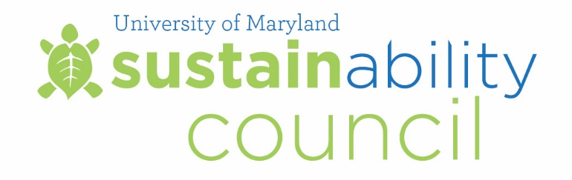

Meeting Summary
March 9, 2018

Council Members Present:

Carlo Colella, Vice President for Administration and Finance (Chair)
Linda Clement, Vice President for Student Affairs
Steve Fetter, Associate Provost
Maureen Kotlas, Executive Director, Department of Environmental Safety, Sustainability & Risk
Scott Lupin, Assoc. Dir., Environmental Safety, Sustainability & Risk, and Director, Office of Sustainability
Bryan Quinn, Director of Technical Operation, Department of Electrical & Computer Engineering
David Cooper, Assistant Director of Operations, Division of IT
Eric Wachsman, Professor, Materials Science and Engineering, and Director, Energy Research Center
Mary-Ann Ibeziako, Director, Department of Engineering and Energy
Jelena Srebric, Professor, Mechanical Engineering
Logan Kline, Undergraduate Student, Environmental Science and Policy
Ayana Jones, Graduate Student, Public Health
Meeting start time: 9:00am

Meeting Highlights

Welcome and Review of January 29, 2018 Meeting Minutes

Carlo Colella welcomed the Council members and called the meeting to order. Meeting summary from January 29, 2018 was approved.

President’s Energy Initiatives Taskforce Presentations
Representatives from the President’s Energy Initiatives Taskforce provided five-minute updates about ongoing efforts for campus energy reduction. Copies of the presentations are available as Appendix A.

University Sustainability Fund Projects

Logan Kline, undergraduate representative, presented four University Sustainability Fund projects to the Council for review. Information about the projects are available as Appendix B.

The Council reviewed the following projects:
Student Leadership in Campus Community Expanded
The Council voted to approve the request of $50,000. This project will fund graduate assistants and undergraduates to implement parts of up to 60 sustainability projects that were developed last year in the municipalities of College Park, Hyattsville, Riverdale Park, University Park, Berwyn Heights, and other local communities. APPROVED.

Stamp Vertical Garden
The Council voted to approve the request of $15,000, with the stipulation that the group also gets permission from the Architectural and Landscape Review Board (ALRB). Stamp Student Union proposes to incorporate a biowall - designed by Plant Science and Landscape Architecture students and installed by a contractor - in the enclosed patio area on the south side of the building. Part of the wall includes an herb garden to be used by Adele’s restaurant and the catering department in the building. APPROVED with one stipulation.

Team Omega
The Council voted to approve the request of $2,500. This Gemstone team's goal is to create a novel source of omega-3 fatty acids using genetic engineering techniques as an alternative to environmentally harmful fishing practices currently used to collect omega-3 from fish. APPROVED.

Team Oysters
The Council voted to approve the request of $1,616. This Gemstone team, which received a Sustainability Fund grant previously, is expanding its research to investigate if the use of a 3D printing filament containing calcium carbonate can provide an alternative substrate for oyster restoration that is more efficient compared to other inorganic substrates. APPROVED.

Open discussion items
- Scott Lupin thanked Aynsley Toews for her contribution to the Office of Sustainability and the University Sustainability Council. Aynsley accepted a position with the Center for Leadership & Organizational Change (CLOC).

Adjourn 11:00am

